

Design Guide

**COVID-19**

|  |  |
| --- | --- |
| Faculty Name | Miss. Wajiha Siddiqui |
| Batch Coordinator Name | Miss. Maham Haider |
| Batch Code | 2308B1 |
| Group | A |

|  |  |
| --- | --- |
| Enrollment No. | Student Name |
| Student1503124 | Omymah |
| Student1500557 | Ahmed Raza |
| Student1499166 | Muhammad Affan Vohra |
| Student1501352 | Arooba Jahan |
| Student1501393 | Ayesha |

**ACKNOWLEDGEMENT**

**We express our sincere gratitude to our faculty “--Miss Wajiha Siddiqui--" and our coordinator for their amazing support and guidance, continuous encouragement and supervision throughout the course of the present work. It’s of no doubt that we have been very fortunate to work under such a supportive and cooperative teacher/coordinator and last but not the least we are extremely grateful to the whole faculty and administration of Aptech, for providing us all the facilities that were mandatory, without which this project could not be a success.**

**SYNOPSIS**

#### **Project Overview**

The **COVID-19** Vaccine Management System is a web-based application designed to manage and streamline the distribution, administration, and tracking of **COVID-19** vaccines. The system is developed using a combination of front-end and back-end technologies, including HTML, CSS, JavaScript, Bootstrap 5, MySQL Workbench, and PHP. This platform ensures efficient scheduling, record-keeping, and reporting for vaccine providers and recipients.

#### **Technologies Used**

1. **HTML:** Used to structure the web pages and content.
2. **CSS:** Applied for styling the website to ensure a visually appealing and responsive design.
3. **JavaScript (JS):** Implemented for client-side scripting, enhancing interactivity and dynamic content handling.
4. **Bootstrap 5:** Utilized for creating a responsive and mobile-friendly layout, along with pre-designed components.
5. **MySQL Workbench:** Employed as the database management tool to design, model, and maintain the database schema.
6. **PHP:** Used for server-side scripting to handle data processing, form submissions, and interactions with the database.

# **PROBLEM DEFINITION & CUSTOMER REQUIREMENT SPECIFICATIONS (CRS)**

# System Modules:

# **Admin**

# All Patient details

# Report of Covid test/vaccination

# Test report, Vaccination (Date/week/monthly report)

# List of vaccine

# o available or unavailable

# Approval Hospital Login

# List of hospitals

# Booking Details

# **Hospital**

# Register

# Login

# List of patient details

# Request from patient (Covid test/Vaccination)

# o Approve or Reject

# Update Covid test result

# Update Vaccination status

# **Patient**

# Register

# Login

# Search Covid Test/Vaccination hospital

# Request for Covid Test/Vaccination for hospital

# Report of covid test/Vaccination taken

# Book Hospital appointment

# My Appointment

# View Results

# My profile

# Modules Description

# **Admin**

# All patient details

# View all patient profile details

# Report of COVID – 19

# patient, COVID – 19 test report (Date wise report)

# Admin can export the details in xls format by date, week and month wise report

# List of vaccine

# available or unavailable

# Admin can view the availability of the vaccination

# Approve Hospital Login

# Approve or Reject

# Once the request for appointment from patient side, it will be approved from the admin

# List of hospitals

# Admin can view the hospital details

# Booking Details

# Admin can view the booking details from patient side for booking COVID – 19 test results

# **Hospital**

# Register & Login

# Can register and login into the app with hospital name, address and location details.

# List of patient details

# Hospitals can be view the patient details who are all approve for COVID –19 tests.

# Request from patient

# Hospitals can be request to the patient from the hospital side who are all approved / rejected for covid – 19 test / vaccination.

# Update covid – 19 result

# Hospitals will be updated the patient’s covid – 19 results.

# Update vaccination status

# Hospitals will be updated the patient’s vaccination status.

# **Patient**

# Register & Login

# Patient can register and login into the app with patient name, address and location details.

# Search covid-19 / vaccination hospital

# Patient Can search the covid-19 hospitals and get from the vaccination hospitals

# Request for covid-19 test / vaccination hospital

# A Patient Can request to the hospital for the covid-19 test. It will approve patient can take vaccination from the hospitals

# Report of covid test/Vaccination taken

# A Patient can take the covid-19 test result report and their suggestion vaccination.

# Book Hospital appointment

# A Patient will booking the appointment from the hospitals and tested the covid-19 tests.

# My Appointment

# A Patient will check the appointment timing and hospital details from the My Appointment module.

# View Results

# A Patient can view their covid-19 test results and vaccination suggestions also.

# My profile

# A patient will check the profile details and also edit or delete the other information also.

# **SCOPE OF THE WORK**

# We created the **COVID-19** Vaccine Management website to address the critical need for an efficient, centralized platform to manage and streamline the complex processes of vaccine distribution and administration during the pandemic. As the global response to **COVID-19** required unprecedented coordination and speed, it became clear that a dedicated digital solution was essential for optimizing vaccine logistics, ensuring equitable access, and maintaining real-time oversight. This website was developed to provide a user-friendly interface for healthcare providers, government agencies, and the public, facilitating accurate tracking of vaccine inventories, appointments, and distribution metrics. By offering comprehensive information and resources, the platform aims to enhance public trust, reduce vaccine hesitancy, and contribute to the overall effectiveness of vaccination efforts, ultimately supporting the global fight against **COVID-19** and its variants.

# **SCREENSHOTS**

**PATIENT REGISTERATION**

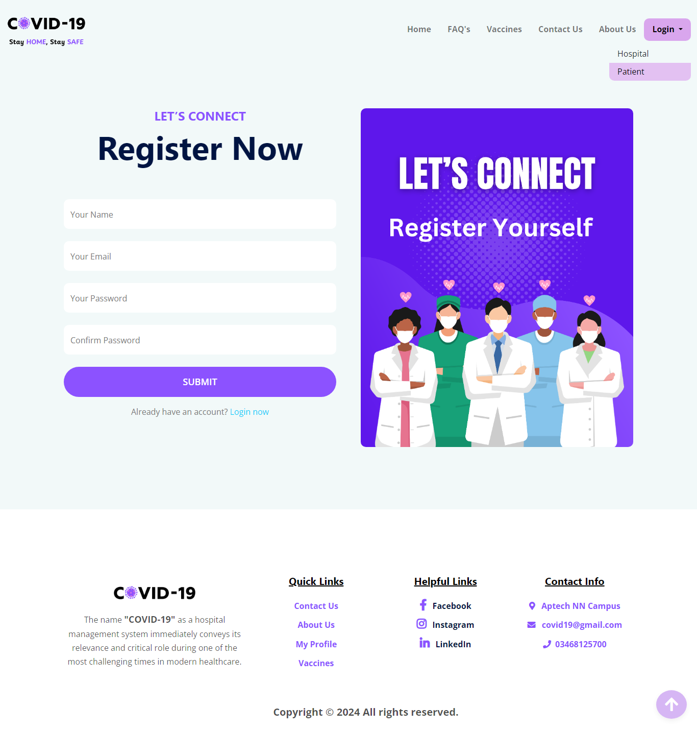

**PATIENT LOGIN**

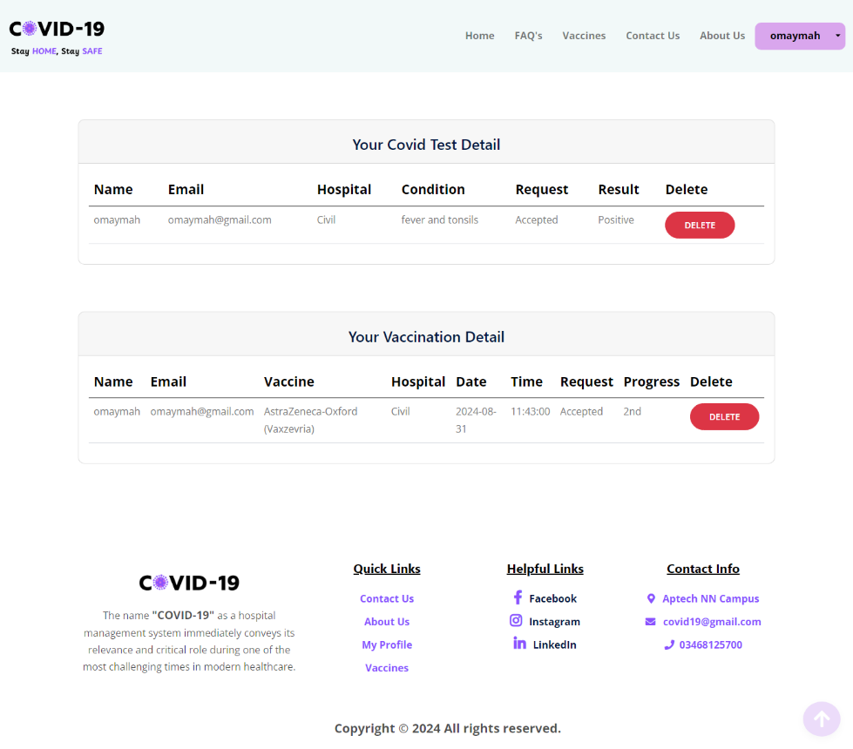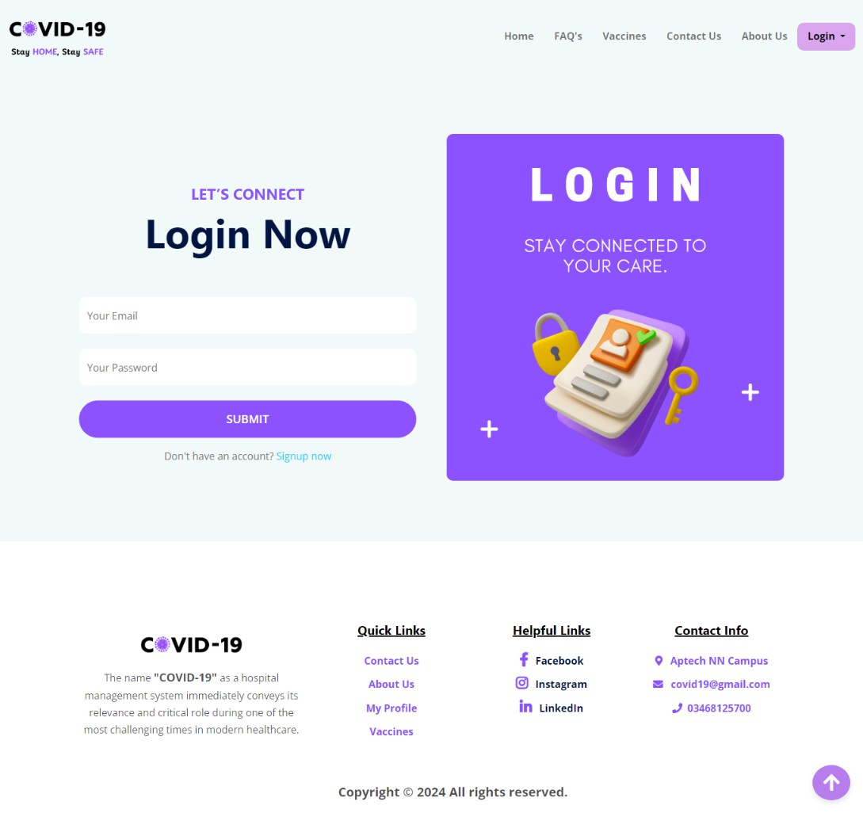

**MY PROFILE**

**INDEX PAGE**

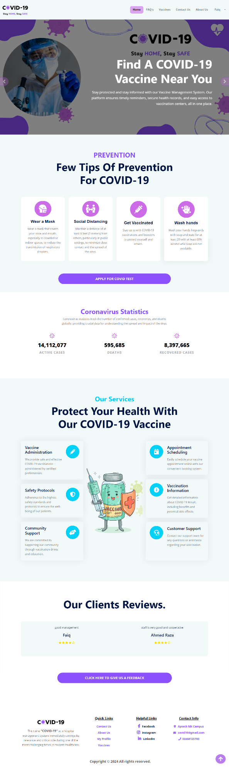

**FAQ’S PAGE**

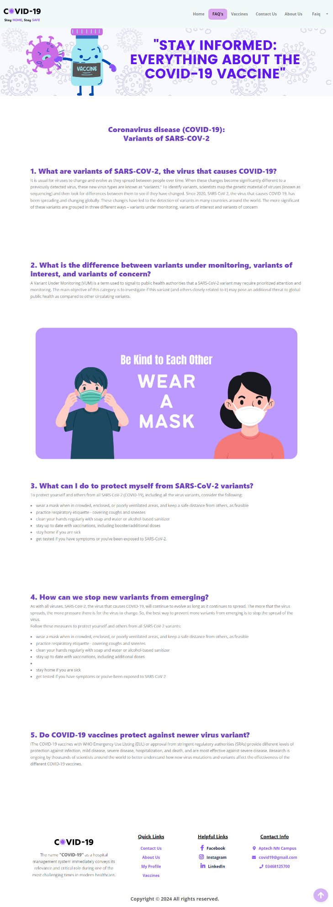

**ABOUT US PAGE**

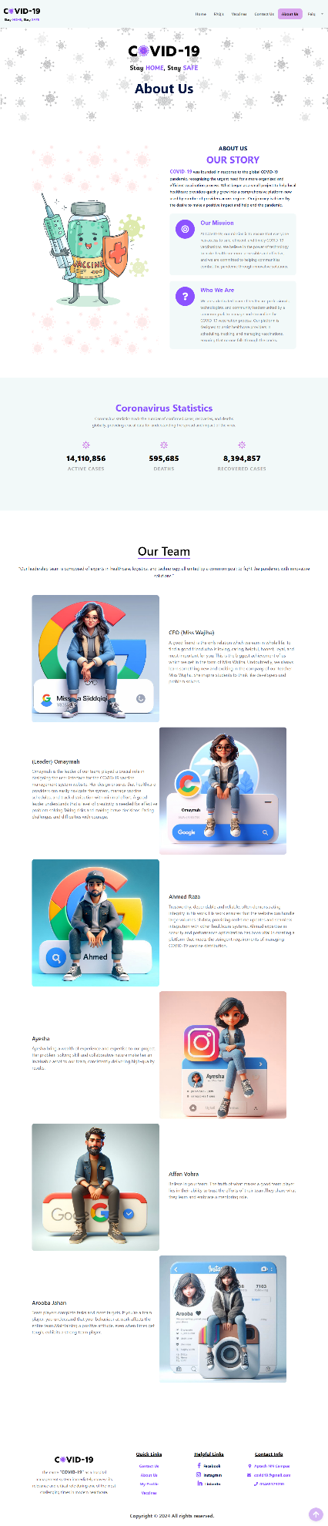

**CONTACT US PAGE**

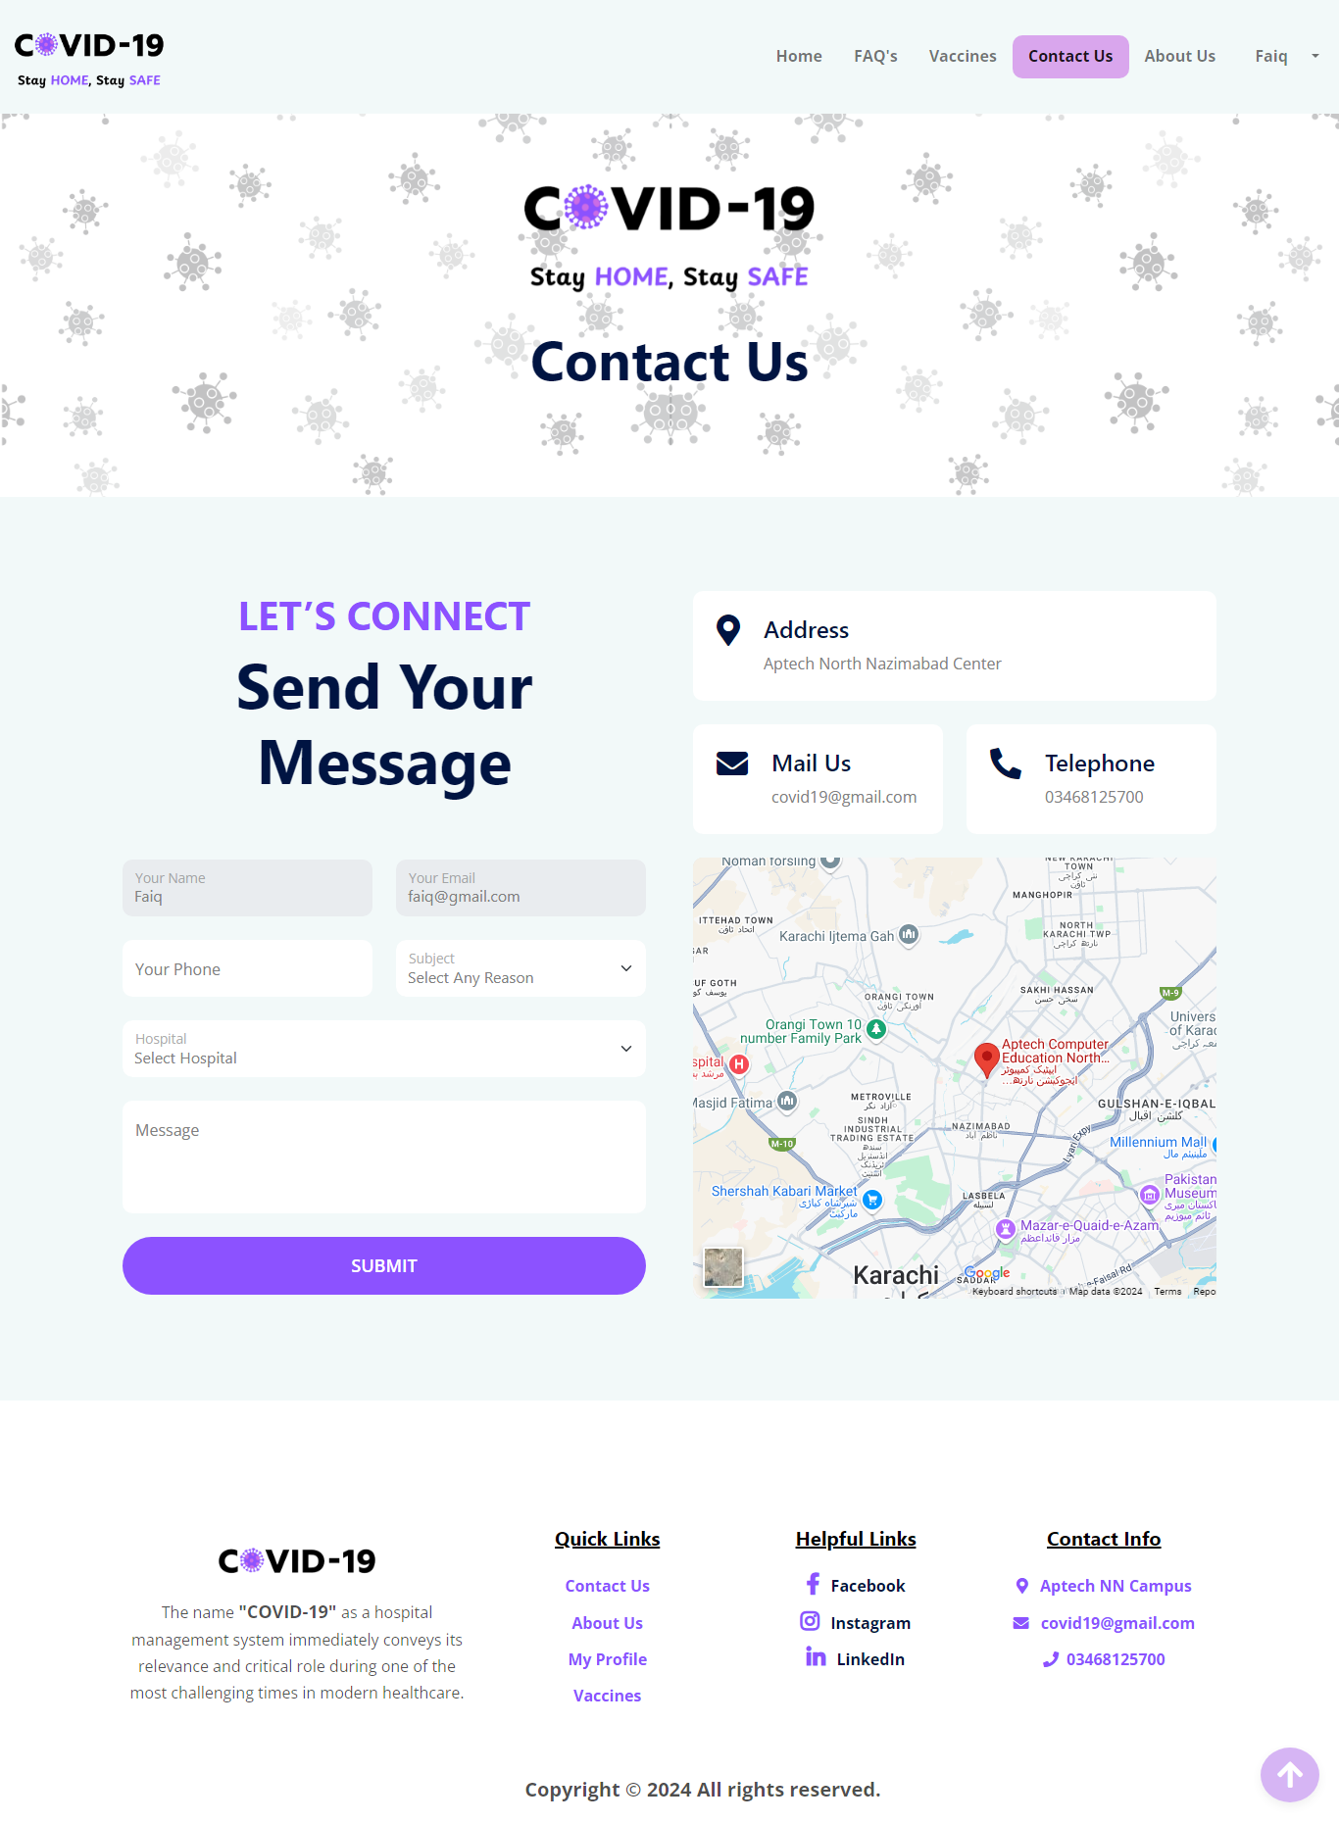

**VACCINES AVAILABLE PAGE**

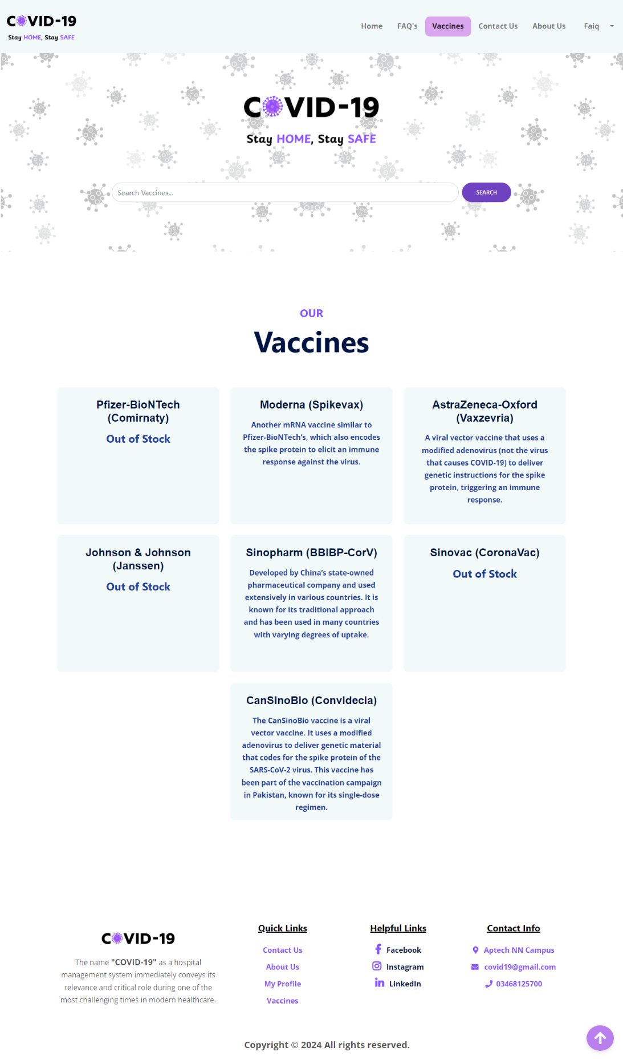

**FEEDBACK FORM**

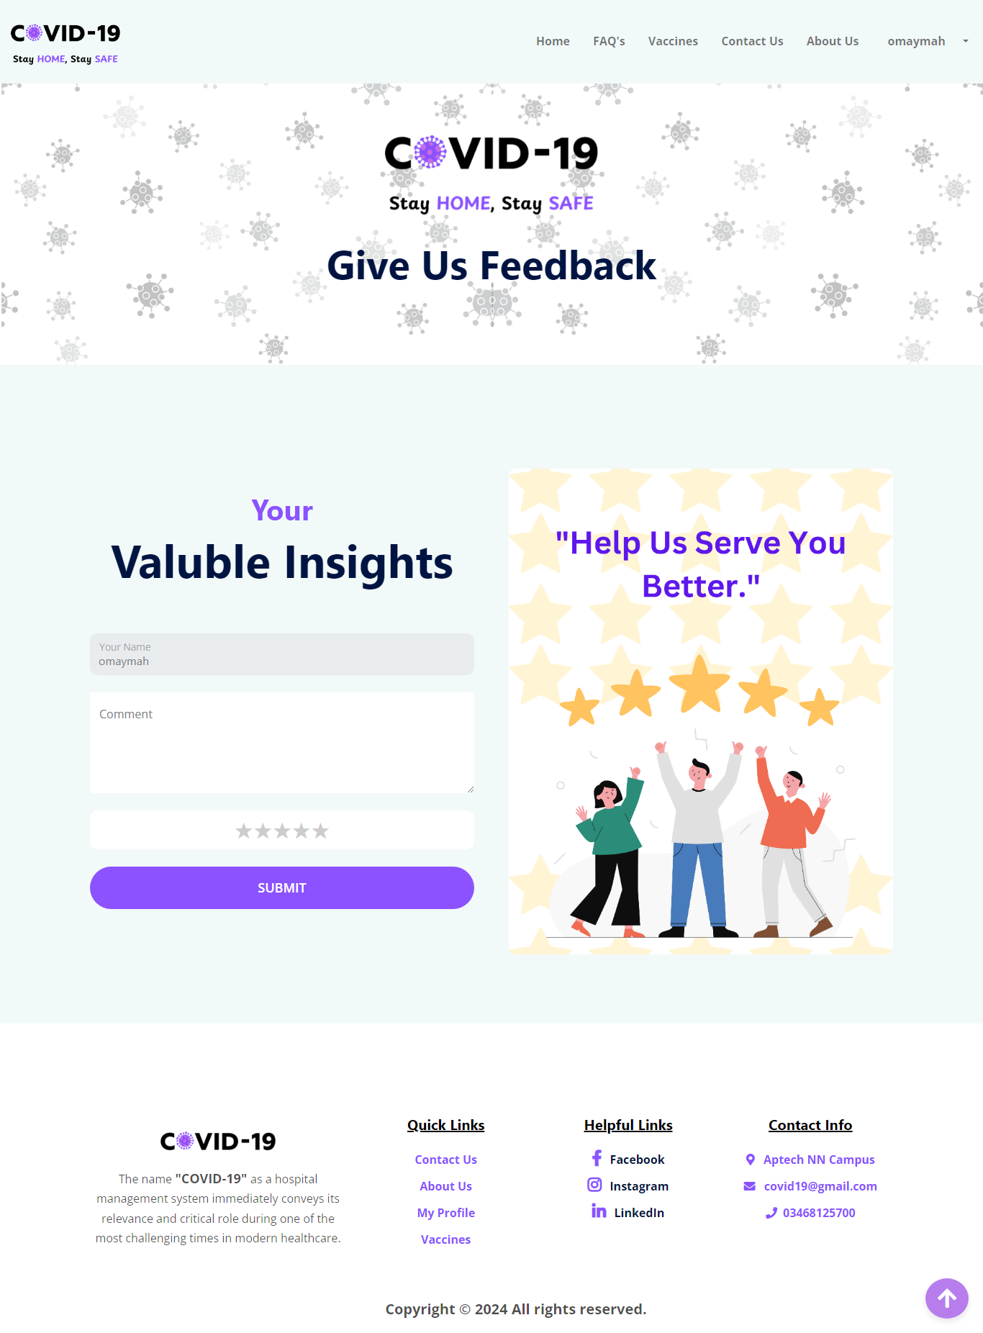

**VACCINE APPOINTMENT FORM**

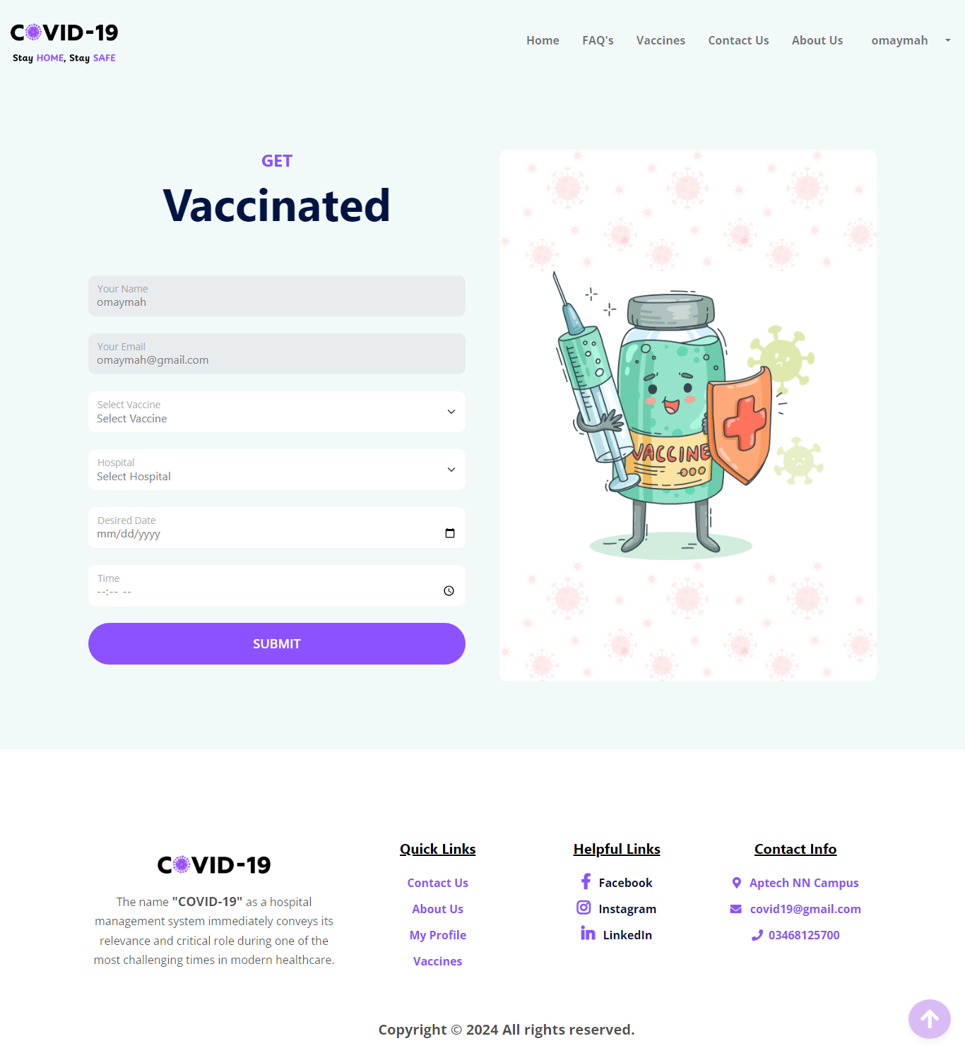

**COVID-19 TEST FORM**

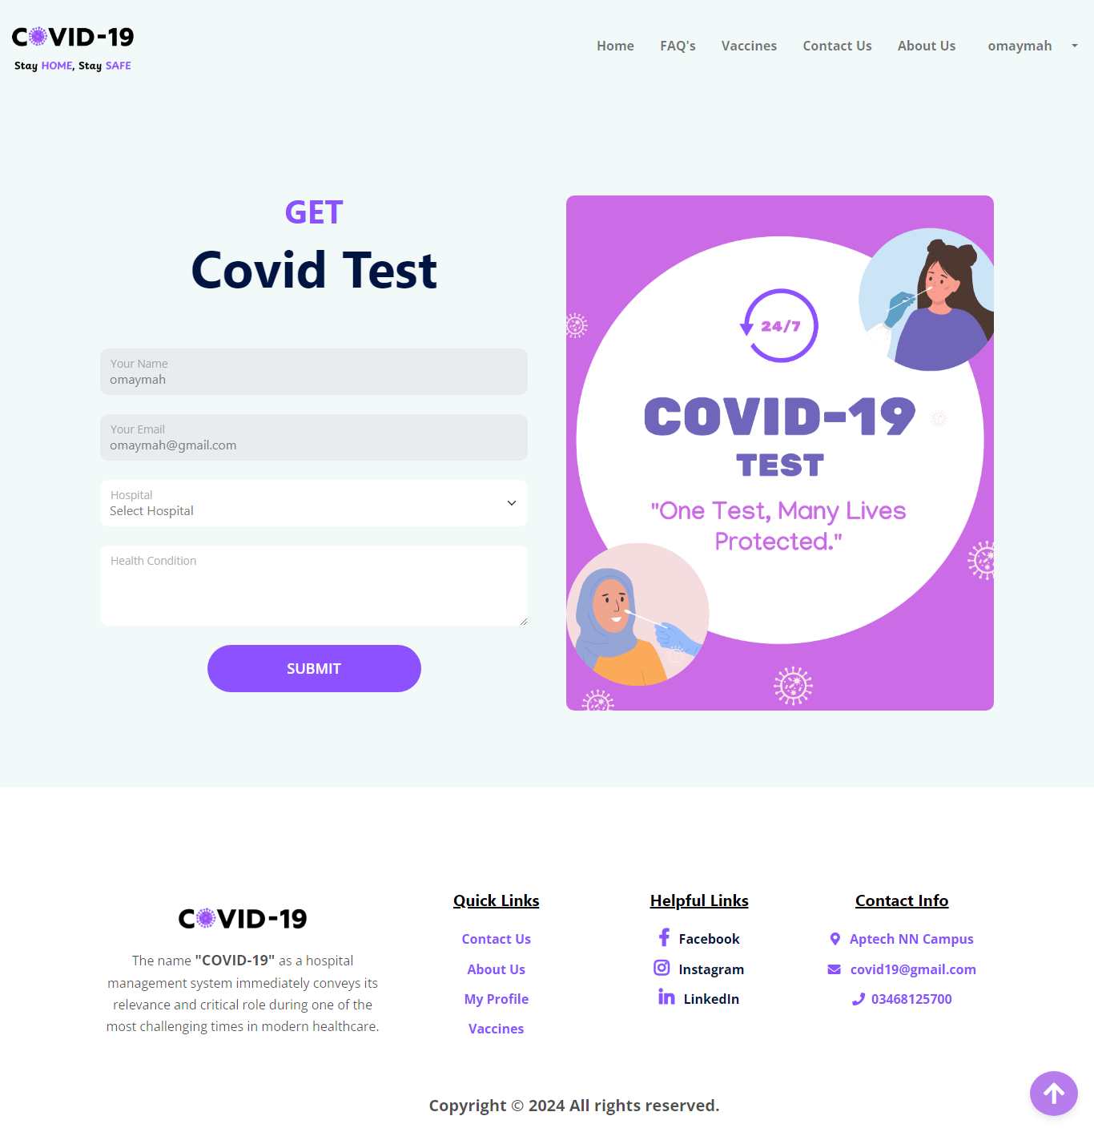

**HOSPITAL REGISTRATION FORM**

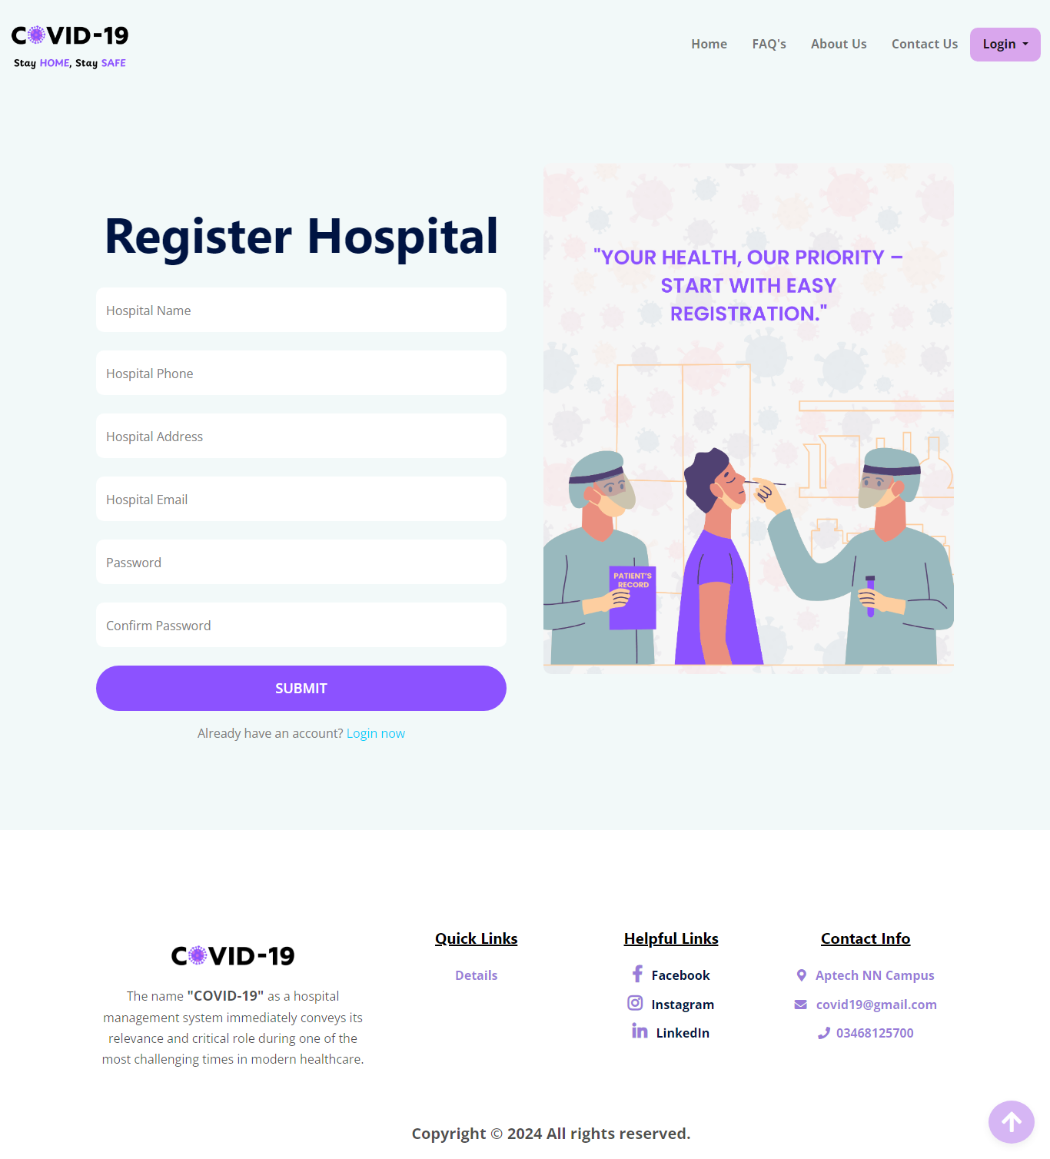

**HOSPITAL LOGIN FORM**

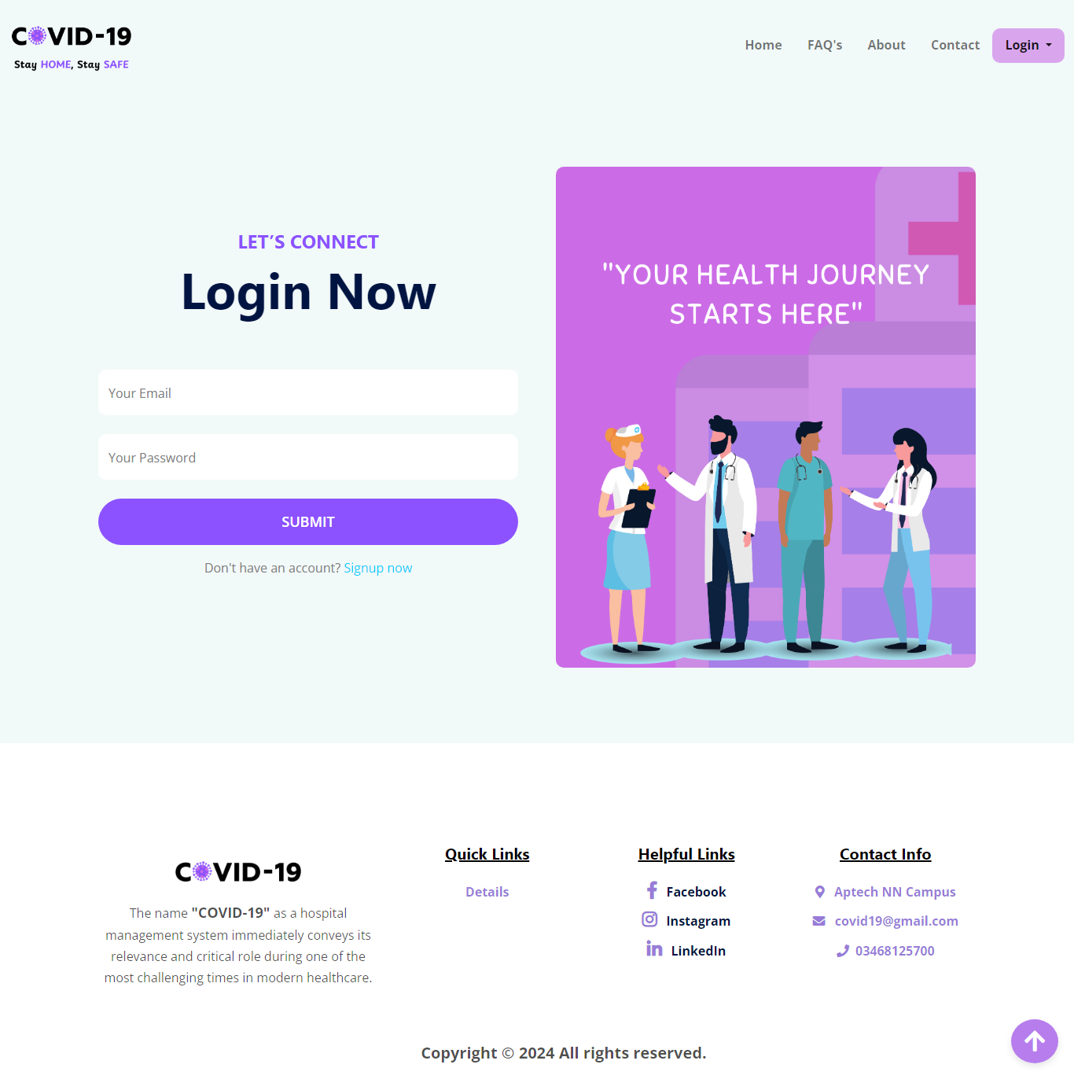

**HOSPITAL INDEX**

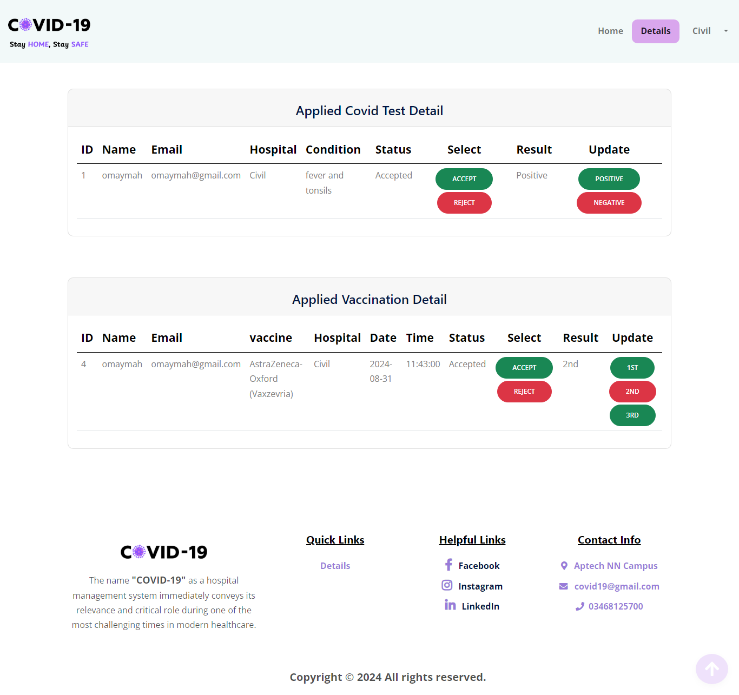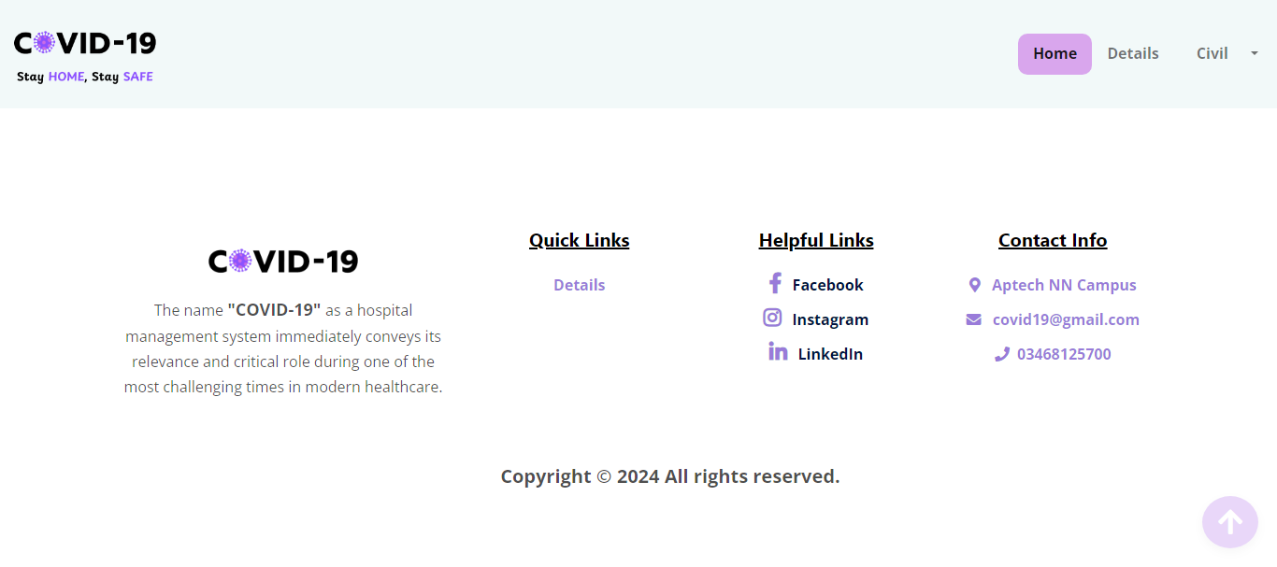

**HOSPITAL DETAILS**